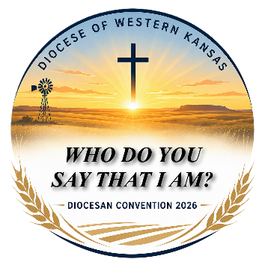
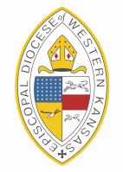

TABLE OF CONTENTS:
WORKING PAPERS
for the
FIFTY SIXTH
ANNUAL CONVENTION
EPISCOPAL DIOCESE OF WESTERN KANSAS OCTOBER 16-17, 2026, Dodge City, KS
Hosts: Sts. Mary & Martha & St. John’s, Great Bend

Convention Decorum__________________________ Page 1

Convention Schedule__________________________Page 3

Dispatch of Business__________________________Page 4

2026 Convention Committees____________________Page 7

Report of Resolutions______________________________ Page 8

Report of Canonical Amendments____________________ Page 8

First Report of the Nominating Committee___________Page 9

Biographical Information of Nominees _________________ Page 10

Financial Reports
Comments___________________________________ Page 12
2025 Endowment Fund__________________________ Page 13
2026 Diocesan Financial_________________________ Page 15
2027 Budget Overview__________________________ Page 17
Sheaf of Reports_______________________________ Page 19
Lay Delegates to the 2026 Convention______________ Page 19
Necrology List_________________________________ Page 20

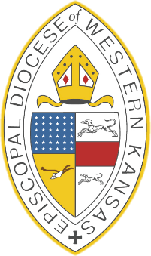

Episcopal Diocese of Western Kansas

Diocesan Convention 101 Rules and Procedures.

Episcopal Diocesan Conventions are the cornerstone of governance for our diocese. The Convention, governed by a specific set of rules, brings together clergy and lay representatives to legislate, set vision, and oversee the administration of the diocese. These rules define how decisions are made, how leadership is elected, and how the diocese aligns with broader church values and policies.

- When you first address the Bishop, such as when speaking from the floor or at the podium, use his formal title—most commonly, “Right Reverend Sir.”
- In conversation or less formal remarks, “Bishop” followed by their last name is widely accepted and respectful.
- The Bishop will call for all motions, and votes.
- Membership: The Convention consists of the bishop (or bishops), all eligible clergy canonically resident within the diocese, and lay delegates elected from each parish or mission.
- Officers: Conventions are presided over by the Bishop, with support from elected officers such as the Secretary, Treasurer, and Chancellor.
- Committees: Various committees—like those for credentials, resolutions, and nominations—facilitate the Convention’s business and ensure transparency and order.
- Reports and Presentations: Key diocesan officers, committees, and affiliated organizations present reports, providing transparency and accountability.
- Open Participation: While only elected delegates and clergy have voice and vote, conventions often welcome visitors and observers, fostering a spirit of openness.
- When addressing the convention remember to use the microphone so everyone can hear what is being said.

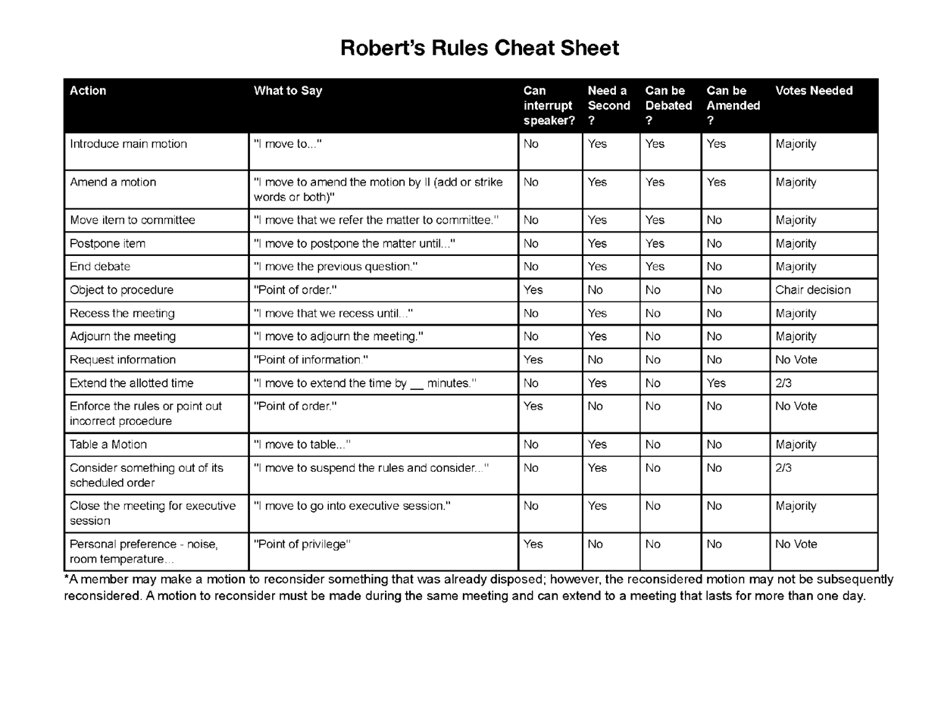

Proposed Convention Schedule
Episcopal Diocese of Western Kansas Fifty Sixth Annual Convention
October 16-17,2026 Dodge City, KS.
Host: Sts. Mary & Martha, Larned and St. John’s, Great bend

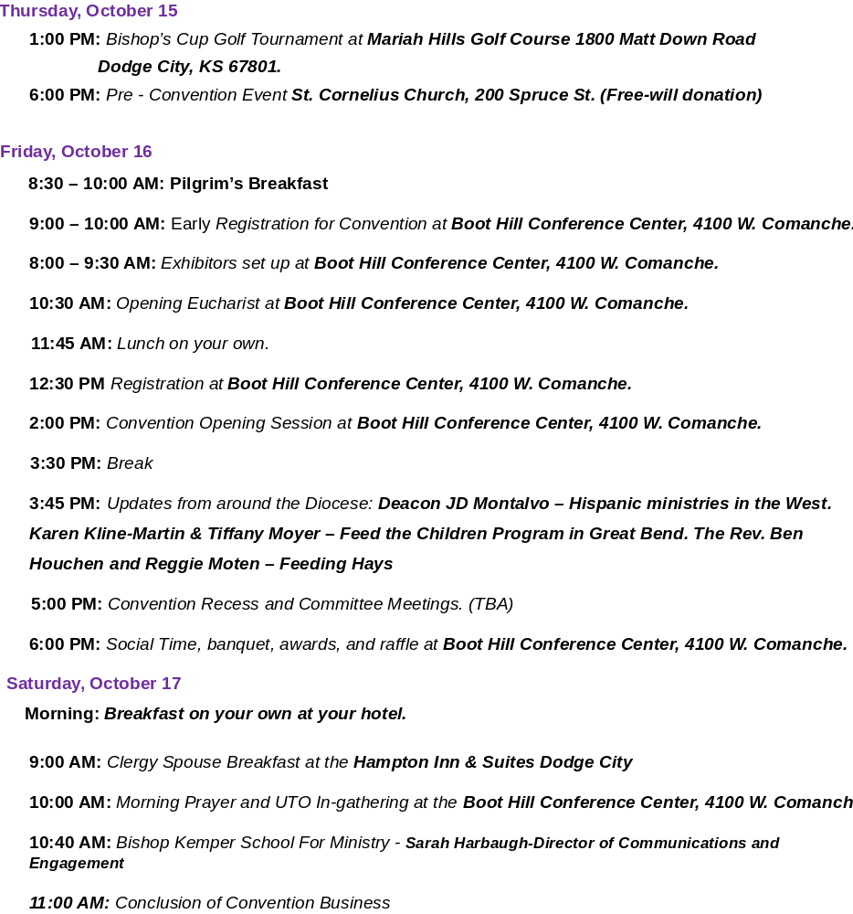

DISPATCH OF BUSINESS

Episcopal Diocese of Western Kansas 56th Annual Convention
October 16-17, 2026, Dodge City, KS
Host: Sts. Mary & Martha, Larned and St. John’s, Great Bend
Reverend Clergy, Delegates, Ladies and Gentlemen, Honored Guests, the Dispatch of Business asks that you move and adopt the following order of business:

The Schedule of Business The Order of Business
The Special Order of Business

We move that the following schedule be adopted for this Convention:

Friday, October 16, 2024
2:00 P.M. 1st LEGISLATIVE_SESSION:
- Opening prayers
- Call to order
- Appointment of Dispatch of Business
- Report from Dispatch of Business
- Welcome to Dodge City
- Election of Parliamentarian
- Election of Convention Secretary
- Introduction of appointed Tellers
- Seat and Voice
- Committee on Credentials
- Announcement of a quorum
- Dispatch of Business
Reports:
- Resolutions Committee
- Presentation from the Budget Committee for the 2027 budget (not open for discussion or action currently).
- Constitution and Canons
- Nominations Committee: Nominations may be received from the floor.

3:30 P.M. Break and Refreshments

3:45 P.M. 3:45 PM: Updates from around the Diocese: Deacon JD Montalvo – Hispanic ministries in the West. Karen Kline-Martin & Tiffany Moyer – Feed the Children Program in Great Bend. The Rev. Ben Houchen – Feeding Hays in Hays.

5:00 P.M. Hearings, Committee Meetings – TBA

6:00 P.M. Social Time, banquet, awards, and raffle and auction.

2nd LEGISLATIVE SESSION: Saturday, October 17
9:00 A.M. Clergy Spouse Breakfast – Hampton Inn and Suites
9:00 A.M. Pilgrims Breakfast- Lobby of Convention Center
10:00 A.M. Morning Prayer and UTO Ingathering at the Convention Center
11:00 A.M. Legislative Session Continues to conclude Convention Business
Dispatch of Business
- Credentials
- Report from Committee on Resolution – discussion and action
- Report from Committee on Constitution & Canons – discussion and action
- Elections
- Reports from selected Committees and Officers
- Financial Report of the Diocese
- Vote of 2026 budget – discussion and action
- Diocesan appointments
- Time and place of future conventions
- Congratulations and Gratitude
- Dispatch of Business
- Announcements
- Adjournment
We so move.

Be it further moved, the following special order of business be adopted.
- The Bishop’s address has been given during the Opening Eucharist on Friday October 16.
- Friday’s free will donations from the potato bar will benefit St. Michael’s Feeding Hays Ministry.
- The Necrology Report will be given during the Morning Prayer on Saturday.
- Offerings from the Convention Worship service will be used to support the mission funds for Deacon JD Montalvo and Deacon Josiah Smiddy.
- That this Convention sends greetings to The Rt. Rev. Michael & Kathy Milliken, The Rt. Rev. and Mrs. Vernon Strickland, The Rt. Rev. and Mrs. James M. Adams, Jr, Mary Viel and The Rev. Tom & Karen Kerchen as the convention remembers The Rev. Brian Viel and The Rev. Eileen Heden.
- That any special order of business may be adopted by a two-thirds vote of the voting members present at this convention, providing there is a quorum of the House present.

We so move.

DIOCESAN CONVENTION COMMITTEES FOR 2026

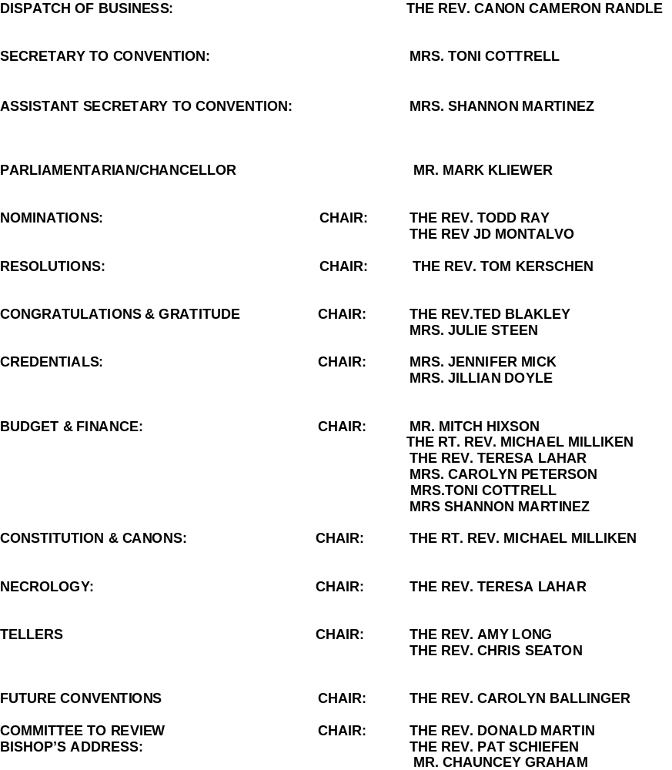

REPORT OF THE RESOLUTIONS COMMITTEE 2026

NONE

REPORT OF THE CANONICAL AMENDMENTS 2026

NONE

FIRST REPORT OF THE NOMINATING COMMITTEE
These are the Nominations as of October 10, 2026

Trustees for the Diocese of Western Kansas - Two clergy and three lay members to be elected for a two-year term and One Clergy Member for a one-year term.

Clergy: The Rev. Todd Ray (1year), The Rev. Eric Anderson, The Rev. JD Montalvo

Lay: Mrs. Carolyn Peterson, Mr. John Helmer, Mrs. Georgia Briery

Incumbents: The Rev. Chris Seaton, Mrs. Kathleen Malone Crouch

COMMISSION ON MINISTRY – One clergy and One lay members to be elected for a two-year term
(One clergy for a two-year term, and one lay person and a chairperson from the clergy order to be appointed by the Bishop)

Clergy: The Rev. Carolyn Ballinger, The Rev. Sandra Herder (appointed)

Lay: Mr. Butch Pyle, Mrs. Kathy Haxton (appointed)

Incumbents: The Rev. Ben Houchen, The Rev. Don Martin, Mrs. Jennifer Higgins, Mrs. Sara Kirkhart

THE DISCIPLINARY BOARD – 2 Clergy Member and 1 Lay Member to be appointed by the Bishop for
a three-year term.
Incumbents: Rev. Karen Lemon (27), Mr. Steve Fontaine (27), The Rev. Cameron Randle (28),
Mrs. Toni Cottrell (28)

NOMINATIONS CAN BE MADE FROM THE FLOOR

BIOGRAPHICAL INFORMATION ABOUT THE NOMINEES

Trustees for the Diocese of Western Kansas
The Rev. Todd Ray: I have been a member of Grace Episcopal, in Hutchinson, for 9 plus years. I attended (in person and virtually due to Covid) BKSM. I was ordained into the diaconate June 19, 2021. I have been on the commission on Ministry and a Trustee. I am a retired teacher who now works at Elliott Mortuary in Hutchinson. Susie and I have 2 sons and 3 grand girls.
The Rev. Eric Anderson: My career in the church began in 1988 when I moved from California to attend an ELCA seminary in Iowa. After graduating in 1992, I was hired at an Episcopal Church in the Diocese of Newark. I was received into the Episcopal Church. Bishop Spong commissioned me to serve as a chaplain to an outreach ministry for gays looking for a safe place to worship.
I moved to Japan for three years. When I returned, I was ordained a deacon then a priest. I served two positions in the Diocese of Washington; Associate Rector and Episcopal Day School chaplain. I took the position of Rector in the Diocese of Kansas. Then I finished a year of Clinical Pastoral Education in Wichita and then was hired as a hospital chaplain in KCMO in the Diocese of West Missouri. I remained there for a number of years. I moved to Kansas and became the Director of bereavement at a hospice in Salina. When asked to become a priest at the cathedral I transferred to the Diocese of Western Kansas. I am now serving at Trinity Episcopal Church in Norton, Kansas.

Mrs. Georgia Briery: I am a lifetime member of Trinity Episcopal Church in Norton Kansas. I have served as Church Warden for several years and am an active member of the Altar Guild. I attended PECUSA as a child and later served on the PECUSA Board. I also was the camp nurse for several years. I was a member of the last search committee that eventually elected Bishop Cowell. I have been actively involved in God’s Pantry since its beginning 41 years ago. I am married to Ron and we have a son, Jim and his wife, Heidi. We have 2 grandchildren, Samantha and Andrew. I am a newly retired nurse. I worked 38 years at Norton County Hospital and 20 years at Larned State Hospital. I have loved my years of being a nurse. I would be honored, if elected, to serve you and the Diocese.

Mr. John Helmer: I have been an Episcopalian my entire life. My father, Brother and nephew are all Episcopal Priests. I have been a member of St. Anne’s McPherson since 1982. During that time, I have served on the Bishop’s Committee, and have also served as Junior Warden and currently am the Senior Warden. I have served on the Commission on Ministry for the diocese, as well as the Resolution’s and Cannon’s committee. I spent most of my professional career in EMS as a Paramedic, Crew Captain, and EMS Director until my retirement in 2023. I am currently doing case management for TECH, Inc. in Hutchinson working with persons with Intellectual disabilities. My Wife Linda and I have been delegate to the Diocesan convention for many years. We currently live outside of Hutchinson and keep ourselves busy with our horses, Chickens, and all the fun that goes into having land.

Commission on Ministry
The Rev. Carolyn Ballinger: Carolyn has recently returned to Western Kansa after teaching Navajo children in Bluff, UT. She has been a Vicar I Garden City, Ulysses and Liberal. Before her ordination in 2014, she was a clinical phycologist and teacher. Carolyn now resides in Larned.

Mr. Butch Pyle: I live in Dodge City, and I have been a rancher all my life. I married Nan (Hendy) in 1974 at St. Wynwallow’s Church, The Lizard, Cornwall, Great Britain. We have 3 children and 6 grandchildren.
I have been a member of the vestry at St. Cornelius’ numerous times during the last 46 years and am
currently a member. I have also served as Junior Warden and Senior Warden. I have previously served
on the Diocesan Council and the Commission on Ministry.
I would appreciate your nomination for the Commission on Ministry, as I would like to
continue to be involved and help support the Diocese of Western Kansas.
Mrs. Kathy Haxton joined St. Luke's Episcopal Church in Scott City, Kansas, in April 2018 and has served as a lay minister since the fall of that year, leading prayer services when a priest is unavailable. Prior to joining the Episcopal Church, Kathy was an active member of the Catholic Church, serving as Altar Society president, teaching catechism for seven years, and serving as a Eucharistic Minister for 15 years. Her years of involvement in both traditions have provided her with a broad background in church service and ministry. Kathy has represented St. Luke's at the Episcopal Diocese of Western Kansas Annual Convention for seven years. She has also served on the church's governing board for five years, first as secretary and currently as Junior Warden. In addition, she is currently serving on the search committee for the western parishes. Kathy and her husband, Rod, reside in Scott City and have two grown children.

COMMENTS ON FINANCIAL STATEMENTS
September 30, 2026

The financial statements of The Diocese of Western Kansas at September 30, 2026 are for the period January 1, 2026, through September 30, 2026 and are unaudited. The assessment income represents income received for the period January 1, 2026, through September 30, 2026, and reflects September assessments received through October 10, 2026. Expenses incurred are for the period January 1, 2026, through September 30, 2026. The financial statements that will appear in the 2026 Journal of the Diocese will be audited as of October 2026.

The audited assets and liabilities of the Endowment Fund represent balances as of December 31, 2025. The audited Endowment Fund statement of assets, liabilities and fund balances are incorporated into the financial statement of the Diocese of Western Kansas at year end and will appear in the 2025 Journal of the Diocese of Western Kansas.

Any additional financial reports not included in this packet are available at the Diocesan Office. The 2025 audit has been completed and is also available for viewing at the Diocesan Office.
2025
Episcopal Church in Western Kansas Endowment Fund Balance Sheet

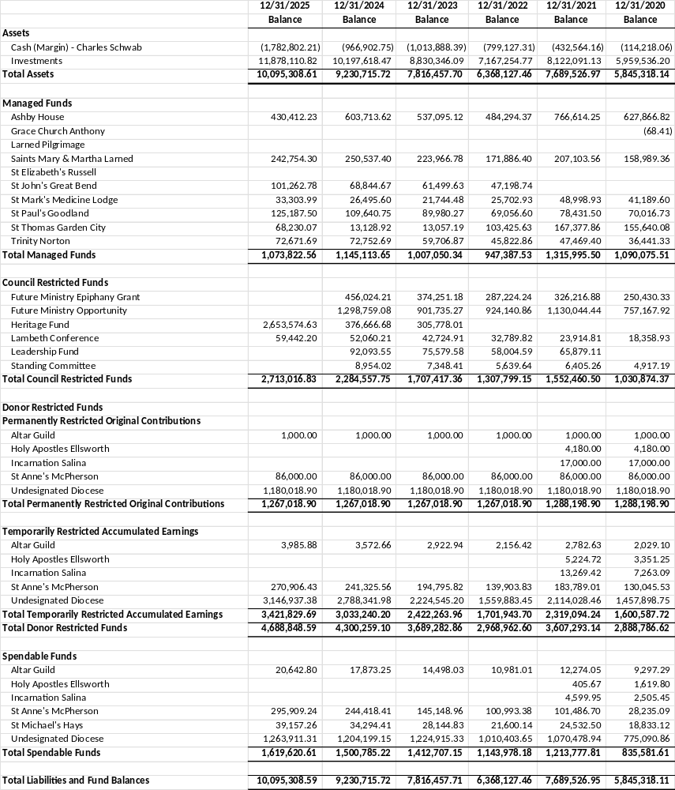

2025 Episcopal Church in Western Kansas Endowment Fund Funds Statement

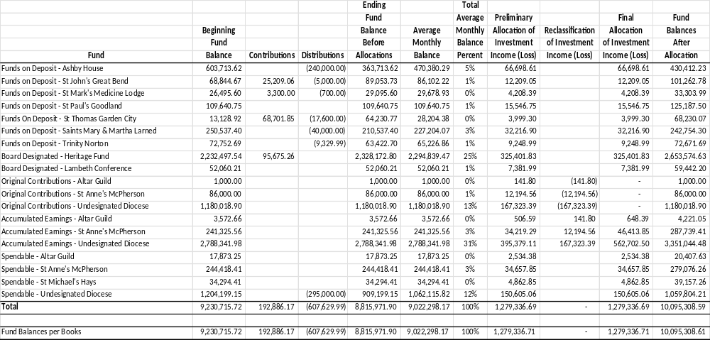

Profit & Loss Budget Performance* Other Financial Statements are available for review in the Diocesan Office*Assessment Income reflects September Assessments received through 10/10/2026.
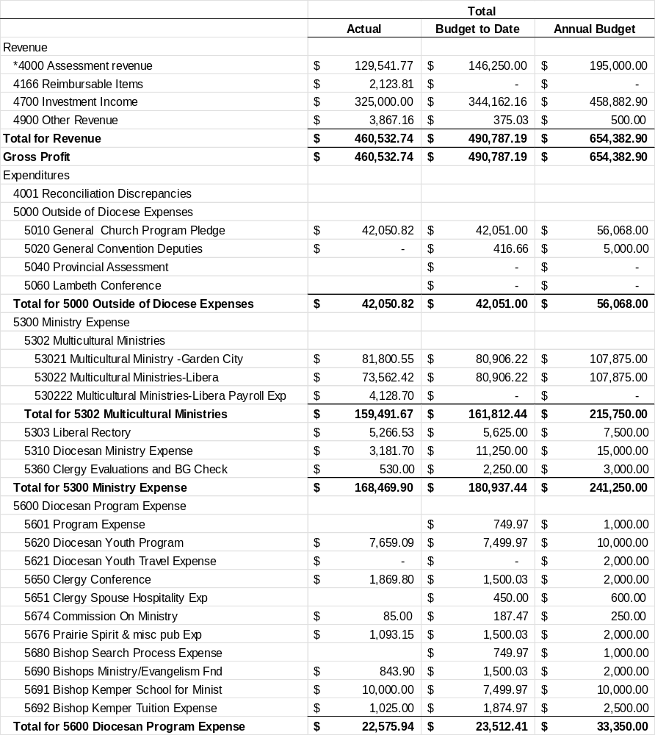

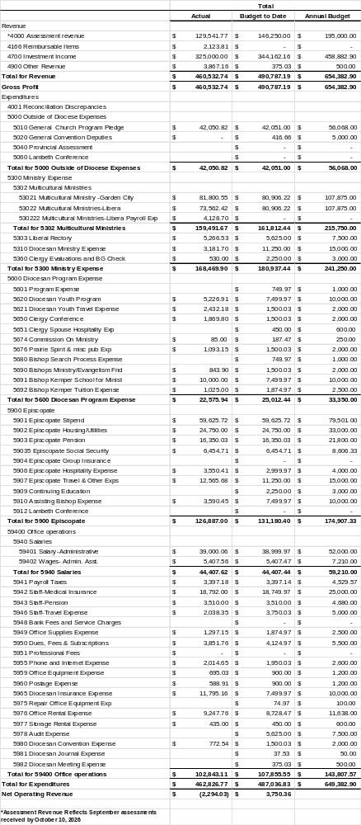
Profit & Loss Budget Performance (cont.)

2027 Proposed Budget
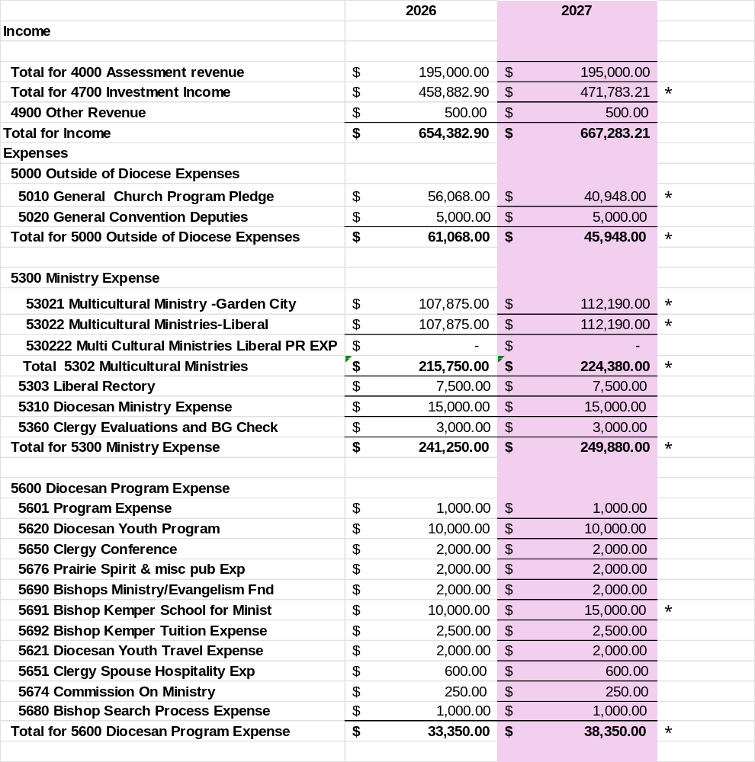

2027 Proposed Budget (contd.)

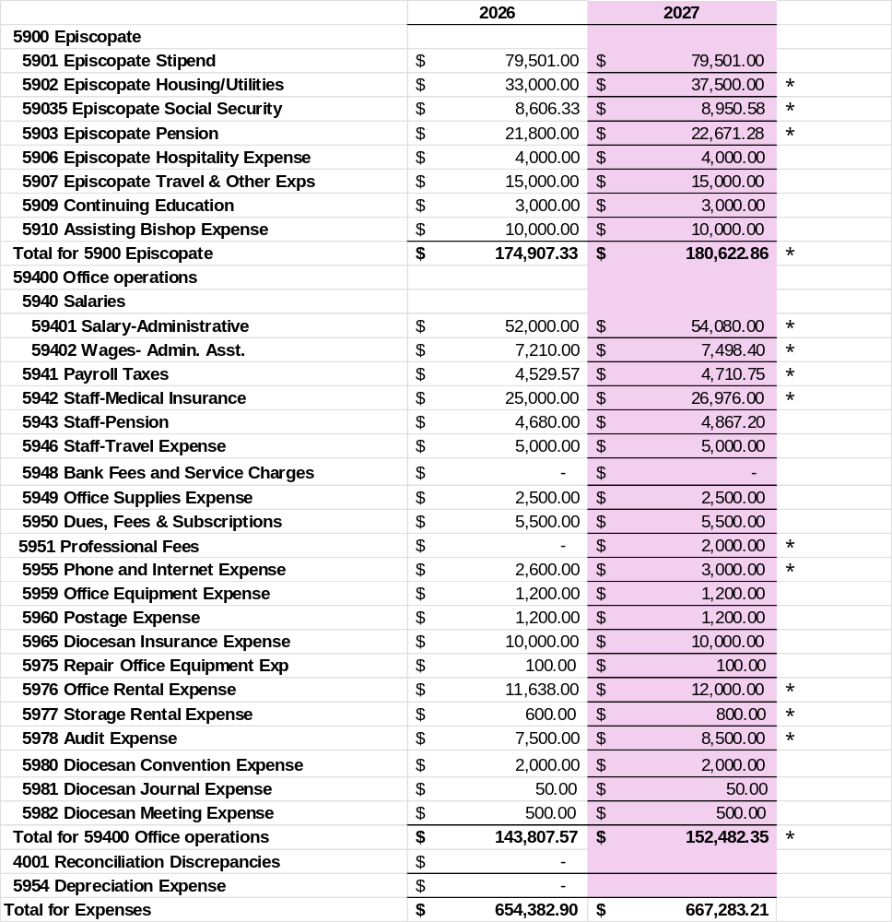

SHEAF OF REPORTS

DIOCESE OF WESTERN KANSAS

TO THE FIFTY SIXTH ANNUAL CONVENTION

These reports from diocesan institutions, task forces, committees, special officers, and staff are intended to inform the Convention of progress and accomplishments in the mission the Convention has charged us to do. Please take time to look through them.

INDEX:

A – Trustees for The Diocese of Western Kansas
A - The Standing Committee
B - Commission on Ministry
B - Treasurer’s Report
C - Canon to the Ordinary
D - Endowment Fund Trustees’ Report
E - Episcopal Church Women
E - Secretary of Convention
F – Diocesan Youth

F - United Thank Offering

G - Latino Ministry

A

TRUSTEES FOR THE DIOCESE OF WESTERN KANSAS

During 2026, the Trustees met 4 times. The business of the Diocese was presented and discussed and action taken as needed. As the world continues to evolve, so do the needs and challenges for our Diocese. Sometimes, creativity is the only and wise decision. Replacing clergy continues to be ongoing as Dodge City awaits confirmation of a new priest. The Cathedral is in the midst of a search for a new Dean, and the northwest has a group developing a profile for the churches in that area. Each church in its own way faces change. With the support of a strong Diocesan family, all will prevail, that is God’s will. The Trustees are an active and caring group and ask the hard questions and support ideas that come before us.

Respectfully submitted,
Carolyn Peterson – Secretary

STANDING COMMITTEE REPORT

In each diocese of the Episcopal Church, the Standing Committee is a canonically required, elected body comprised of both laity and clergy members. Its central purpose is to act as the diocesan bishop’s council of advice, and it serves as the primary governing authority when a diocese lacks a bishop.
In the Diocese of Western Kansas over the past year, our Standing Committee has worked closely with Bishop Cowell on many matters relative to financial, legal, and ecclesial decision making. This often involves the purchase or sale of property. We also participate in the formation process for those seeking ordination as deacons and/or priests. Working alongside Bishop Milliken and the Commission on Ministry, we weigh in on the status of aspirants, postulants, and candidates for holy orders.
Finally, our Standing Committee plays an important part in ratifying the election of every bishop elected in every diocese of the Episcopal Church. Since this time last year, we have voted to consent to the election of more than one dozen new bishops across the national church. It is a privilege to contribute to the health and vigor of our diocese and to the leadership of our broader Episcopal Church.
Respectfully submitted,
The Rev. Canon Cameron Randle
President, Standing Committee

B

COMMISSION ON MINISTRY

The Canons of the Episcopal Church direct that the Commission on Ministry shall advise and assist the Bishop in:
- The implementation of the Title III Canons of the Episcopal Church.
- In the determination of present and future opportunities and needs for the ministry of all baptized persons.
- In the design and oversight of the ongoing process for recruitment, discernment, formation for ministry, and assessment of readiness therefor.

This past year the COM has been well served by a group of dedicated clergy and laypersons, including: The Rev. Todd Ray (Grace Church, Hutchinson), The Rev. Scott Mentzer (St. Paul’s, Goodland), The Rev. Ben Houchen (St. Michael’s, Hays), The Rev. Don Martin (Ascension-on-the-Prairie, Colby), Ms. Margie Prewitt (St. Thomas, Garden City), Ms. Debra Mentzer (St. Paul’s, Goodland), Ms. Sara Kirkhart (Ascension-on-the-Prairie, Colby), and Ms. Jennifer Higgins (Christ Cathedral, Salina).

Currently, the diocese has several people at various levels of progress toward ordination, JD Montalvo, who serves as the Hispanic Missioner for the southwest, Mr. Josiah Smiddy, from Liberal, is on the priesthood track at the Bishop Kemper School for Ministry both will be ordained as deacons at our opening Convention Eucharist. Mr. Logan Simon from St. Thomas in Garden City is enrolled at the Bishop Kemper School moving toward the Priesthood. Also in the ordination process is Karen Kline-Martin (St. John’s, Great Bend) who is working with Bishop Cowell and Jane Lindamood (St. Corneilus, Dodge City) who is working with Cameron Randall.

This year saw two special events for clergy and candidates. In early May the diocese sponsored a spiritual retreat at the Heartland Center led by Brother James Dowd from the Incarnation Monastery in Omaha. The in late August we had a Continuing Education Event on Metal Health and Pastoral Care. This was led by the Rev. Canon Kristin Paul, Missioner for Wellness and Mental Health for the Diocese of Western Louisiana. Both were great events.

Respectfully Submitted
The Rt. Rev. Michael P. Milliken
Chair, Commission on Ministry

TREASURERS REPORT

The budget for 2026 will have a few changes from 2025. These changes have been approved by the Trustees for the Diocese during the August 30th meeting via Zoom. These changes are due to needs in the Diocese, and on the recommendation of Bishop Mark and the Diocesan administrator, Toni Cottrell. I will propose the Diocesan assessment is not changed for 2024, and that it should remain at the 15% rate it has been for the last few years. I believe the changes are good and will benefit the Diocese. The budget will be presented during the business meeting on Friday but will not be open for discussion at that time. A meeting will be held at the end of the business meeting for any specific
questions. The budget will be up for a vote on Saturday morning with the floor open for further discussion at that time. I see a bright future ahead for our Diocese and hope you do as well. Thank you for your service to the parish and this Diocese.

Respectively Submitted
Mitch Hixson, Treasurer - Diocese of Western Kansas

C

CANON TO THE ORDINARY

The past twelve months have been a season of both new and continuing Diocesan endeavors, especially in the realm of clergy transition. All of the ‘new’ is welcomed and most of the ‘continuing’ requires a healthy amount of patience and perseverance. We need look no further than St. Cornelius in Dodge City to begin to get a feel for the complexities of our federal immigration system.
A call was extended last year to the Rev. Travis Fernander to serve as the new rector at St. Cornelius. A native of the Bahamas and a single, individual person with no spouse or children, Fr. Fernander remains, at the time of the convening of this body, an active applicant for relocation to the United States. After these many months, the challenge of navigating our U.S. immigration system remains formidable and seemingly fluid. Meanwhile, the stalwart lay leadership at St. Cornelius has done an exceptional job of staying the course and working faithfully with supply clergy to maintain the vitality of the parish’s spiritual life and community presence. We remain hopeful that Fr. Fernander’s tenure as the new rector will begin in the very near future.
At Christ Cathedral in Salina, an interim dean is leading the congregation while the mechanism for calling a new Dean of the Cathedral has been put in place. The Rev. T.J. Tetzlaff, on loan from the Diocese of Chicago, is providing oversight and direction, in league with the vestry, even as a very capable search committee has begun the proactive discernment process that will eventually lead to the selection of a new long-term Dean of the Cathedral.
Proactive discernment is also behind the formation of a new leadership group tasked with exploring a vision of the collective futures of our Northwest churches, should Fr. Don Martin defy all odds and someday, in the remote distance, elect to retire from his present slate of responsibilities. Comprised of both lay leadership and ordained clergy volunteers, this consortium of faith partners has begun to examine the best paths forward for St. Luke’s in Scott City; St. Francis in Russell Springs; Ascension in Colby, and St. Paul’s in Goodland.
A final Eucharist and Celebration of Ministry was observed on March 21, 2026, to commemorate the closing of the Upper Room in Lakin. The service included a time of prayer, shared stories, and thanksgiving for the ministry of Mother Rita Stockton over the course of more than two decades. The legacy of this unique Episcopal house church lives on through the many lives affected by its outreach and Christian formation conducted in, and from, Lakin.
Most recently, planning and/or participation in two citywide prayer vigils solemnized the aftermath of extensive sweeps by Immigration and Customs Enforcement (I.C.E.) in Liberal and Garden City during the fourth week of September. Our diocesan Latino Missioner, Jedidiah Montalvo, was instrumental in the Liberal event while the Canon to the Ordinary contributed to
the execution of the Garden City event. Both individuals are taking an active role in communitywide efforts to respond to the spiritual, emotional, material, and financial needs of those impacted by I.C.E. operations in Southwest Kansas. Members of St. Cornelius in Dodge City have been similarly engaged during this heated and sensitive time.
Overall, 2026 has been a year of change and transition. The dynamic and persistent nature of that process reminds us of the importance of relying steadfastly on the unchanging faithfulness of the Divine for comfort, advocacy, and inspiration. To be able to do so in the context of this great diocese, and in league with our resolute faith communities, is an ongoing honor.

Respectively Submitted
The Rev. Canon Cameron Randle

D

ENDOWMENT FUND TRUSTEES’ REPORT

2025 Report of Activities

The Endowment investments had a good net income last year of $864,593 or 13% on average invested assets. The S&P 500 gained 17% with dividends. Four of the nine securities the Endowment owned had double-digit gains and these nine companies returned a compound average of 13% for the year. Including this gain, these securities have returned a compounded 16% per year including dividends over the past 10 years, versus 11% for the S&P 500. The Trustees bought shares of NVIDIA this past year. The investment gain for the year that was allocated proportionally among the 19 funds based on last year’s average monthly balance for each.

In addition to the investment performance, $192,886 in new funds were received by the Endowment this past year and at the request of the Diocese, the Future Ministries, Leadership, and Standing Committee funds were consolidated into the Heritage Fund. Support for the Diocese has been made possible by many donors over the past 37 years, but by far the largest single donation (other than from stock market gains) was by Donna and Jack Vanier of Salina, who gave the Endowment $542,000 in 2005. This single undesignated donation has produced nearly half of the annual Endowment support for the operation of the Diocese.

Endowed funds were given with the intent that the original gift would be preserved and only investment earnings be used by the beneficiaries. In this way, the gift could “keep on giving” forever. But if all investment earnings were spent annually, only the original gifts would remain, and inflation would eventually erode the value of these gifts. So, we accumulate investment earnings (and losses) in Temporarily Restricted accounts. Then we calculate a Trustee determined 5% of the average of the most recent three years’ Original Contributions and Temporarily Restricted fund balances for each endowed fund as the amount of new money to make available for spending. The 5% amount is then transferred to the corresponding Spendable Fund. Any investment earnings over the 5% transferred are accumulated in the Temporarily Restricted Accumulated Earnings accounts.

This year, $204,107 of new spendable money was made available for use by the Diocese and other beneficiaries. The total Spendable money is now $1,619,621. The Endowment distributed $607,630 to the Diocese and other beneficiaries last year.

Managed Funds are not endowed and may be withdrawn in part or in total by the depositor. Partial withdrawals are permitted upon the request of the depositor or on a regularly scheduled monthly or quarterly basis. Withdrawals of the entire Managed Fund balances may be made in January each year by written notice to the Trustees.

Council Restricted Funds are not endowed and may be withdrawn by the Diocese, subject to these guidelines.
- The Heritage Project Fund balance is $2,653,575 and is for the future mission of the Diocese.
- The Lambeth Fund balance is $59,442 and is to be used to help fund the Bishop’s travel expenses to the
Lambeth Conference.

Respectfully submitted,
R. Michael Beatty, Trustee
Bishop Mike Milliken, Trustee
Toni Cottrell, Trustee

E

EPISCOPAL CHURCH WOMEN

The Episcopal Church Women (ECW) of the Diocese of Western Kansas is an organization of women that exists to support women as we remain committed to serving our Lord Jesus Christ through worship, prayer, service, and fellowship. All women in the Diocese are members of the ECW by their membership in the Episcopal Church.
Our biggest fundraiser of the year is the Basket Raffle at Convention. I want to thank all who contribute and purchase tickets and donate baskets! At last years convention we raised $1,114.00.
Last year we had a women’s retreat, which was held at the Heartland Spiritual Center in Great Bend. Our Keynote Speaker was The Rev. Chistine Kass who is the pastor of the First Presbyterian Church in Hutchinson. “Talitha Koum: Little Girl I Say to You, Get Up” The retreat focused on a detailed look at Jesus’ relationship with women in the gospels. Jesus actually empowers women to not only find their own voice, but to share the Gospels. It was an inciteful presentation. We are working on setting up another women’s retreat in the Spring of 2028. So, stay tuned!
As we move forward, this year we would like to remain dedicated to expanding our outreach and welcoming new members. We look forward to continuing our tradition of service and fellowship and invite all women in the Diocese of Western Kansas to join us in our mission.
Respectfully submitted,
Toni Cottrell

SECRETARY OF CONVENTION

I am honored to serve as Secretary of Convention. Last year, we gathered in Dodge City, hosted by Grace Church in Hutchinson. Delegates from parishes, missions, committees, and affiliated organizations came together to foster dialogue, review diocesan initiatives, and establish priorities for the coming year.
Clergy, lay delegates, and observers represented every region of the diocese. Attendance was recorded and formally approved at the start of the Convention, ensuring that all participants were recognized and able to take part in decisions. We look forward to gathering again this year in Dodge City, Sts. Mary & Martha, Larned and St. John’s, Great Bend as our hosts. They have been working dillengently with the planning to make our convention a success. Our time together feels like a family reunion, offering a welcome opportunity to reconnect.
Respectfully submitted,
Toni Cottrell, Secretary

F

Diocesan Youth Report

Report on Youth Ministries
This year we introduced a new youth diocesan youth event – a spring Lock-In at Christ Cathedral in Salina on April 11-12. Many thanks are due to DeMay Grunden for spearheading the effort to familiarize the youth with our cathedral. Youth gathered for games and fellowship, completed a community service project, took a behind-the-scenes tour of the cathedral, and participated in a Bible study around the theme “Light in the Darkness” (which ironically, was conducted in the darkened cathedral). Bishop Mark taught the youth about cathedral architecture and history. After (some) sleep, youth participated in Sunday morning worship at the cathedral, where worshippers celebrated the efforts of our 3 readers, 2 intercessors, 5 ushers, 7 acolytes, and a bishop’s assistant.
This year’s annual Youth Convention relocated to Camp Mandan north of Dodge City for the weekend of August 22-23. The facilities provided ample space for our usual array of activities around this year’s theme “Who Do You Say That I Am?” and we enjoyed being able to host an event closer to our southwest Kansas youth. Thanks to Andy Treder for being our local camp host (and for securing the amazing pulled pork). In between Bible lessons, small groups, shaving cream wars, and a special camp Eucharist, the youth also elected two youth delegates and two alternate youth delegates to our annual Diocesan Convention. We are grateful to Rylee Mick (Sts. Mary and Martha, Larned), Quinn Saeger, alternate (St. Thomas, Garden City), and Tatum Treder, alternate (St. Cornelius, Dodge City) for agreeing to serve.
Planning is underway for the next Acolyte Festival so that St. Thomas can stop holding the coveted acolyte festival trophy hostage.

Respectfully Submitted,
Rev. Amy and Brandon Long

UNITED THANK OFFERING

2025 was another good year for UTO. We collected $3,668.54 at the Diocesan Convention in Dodge City. We all realize the importance of this mission, and we appreciate all who participated either in using the Blue Box or writing a check.
It is well to remember both dates that Western Kansas designates for UTO Ingathering: once in the spring on Mothers’ Day, and once in the Fall on the 3rd Sunday in September.
I hope most people will try using the Blue Box. It is just a daily reminder to remember the many blessings God has given to each one of us.
We pray that next year will be a blessing for each of you individually, and for the Diocese of Western Kansas.

G

LIBERAL LATINO MINISTRY

This past year has been about learning, building relationships, and cultivating trust. As you can imagine, parachuting
into a new town with no existing relational ties requires a great deal of time and intentionality. Getting to know people,
understanding the culture of a new place, and finding ways to become part of the community is slow work—even
slower than I initially anticipated!
Nevertheless, it has been a meaningful year of making connections and laying the groundwork for deeper
relationships. One unexpected opportunity came through coaching baseball at the Liberal High School, which allowed
me to connect with students and their families, build relationships within the school system, and learn more about our
region and state. (And there may be some middle school girls’ basketball coaching in my future—stay tuned!) Most of
the people I have been connecting with are young adults in their late twenties to mid-thirties, many with young families
and little to no familiarity with the Episcopal Church. Another significant part of this work has been developing a
partnership with New Frontiers, a local nonprofit dedicated to community organizing, voter education, Know Your
Rights workshops, connecting families with legal resources, and helping people develop preparedness plans. I began
volunteering with the organization as a way of building relationships and engaging more deeply with the needs of our
community. New Frontiers has played an especially important role in supporting local families during these past few
difficult weeks. As our partnership continues to grow, we are excited that St. Andrew’s will become a hub for
community meetings, clinics, and educational workshops. Through the relationships formed in this work, and amid the
fear and uncertainty many in our community have been experiencing, several people approached me about
organizing a public vigil. I had the privilege of helping create a space where our neighbors could gather to grieve,
lament, pray, and find solace in one another’s presence, while looking toward a future shaped by acts of mercy and
justice. As I look ahead, I am excited to begin turning these new relationships into invitations—opportunities to gather
around stories, faith, spirituality, food, and liturgy. My hope is to begin this Advent season with a fully bilingual
gathering centered on sharing a meal, exploring Scripture, and engaging in meaningful conversations about faith and
its relevance to our lives today. We hope to introduce participants to some of the larger themes of Scripture, inviting
them to engage with the biblical text personally, while reflecting together on the meaning of Advent and what it might
offer our contemporary world. We conclude each gathering with Compline, offering a gentle introduction to the
beauty and richness of our Anglican tradition. My hope is that these gatherings will become the beginnings of a
community rooted in belonging, shared faith, and meaningful relationships. Please keep us in your prayers as we take
these next steps. May the Lord continue to bless and guide this work!

Respectively Submitted,
Jedidiah Montalvo

LAY DELEGATES TO DIOCESAN CONVENTION
October 16-17 2026, Dodge City, KS
Sts. Mary & Martha, Larned, & St. John’s, Great Bend-Hosts

COLBY: Mr. Abraham Johns
Mrs. Annette Johns

DODGE CITY: Mr. Butch Pyle
Mrs. Nan Pyle
Mrs. Lucy Martinez

GARDEN CITY: Mr. Marvin Feezor
Mrs. Margie Prewitt

GOODLAND: Mrs. Gennifer House
Mrs. Debra Mentzer

GREAT BEND: Ms. Tiffany Moyer
Mrs. Nancy Cale

HAYS (St. Michael’s): Mrs. Michaela VonWeiser
Mrs. Nikki Houchen

HAYS (St. Andrew’s) None

HUTCHINSON: Mrs. Shannon Martinez
Mrs. Julie Steen
Mr. Brandon Long

KINGMAN: Mrs. Nancy Lindt
Mrs. Karen Kerschen

LARNED: Mrs. Linda Hampton
Ms. Juanita Lemon
LIBERAL: Mr. Chuck Bowman
Mrs. Connie Bowman

LYONS: NONE

MCPHERSON: Mr. John Helmer
Mrs. Linda Helmer

MEDICINE LODGE: None

NORTON: Mr. Ron Briery
Mrs. Georgia Briery

PRATT: Mrs. Lu Bitter
Mrs. Beth Montei

RUSSELL SPRINGS: NONE

SALINA: Ms. Jennifer Higgins
Mr. Arthur Jones

SCOTT CITY: Mr. Chauncey Graham
Mrs. Kathy Haxton

YOUTH: Miss Riley Mick
A-Miss Quinn Sager
A-Miss Tatum Treder
A-Miss Lillian Montgomery

2026 NECROLOGY LIST

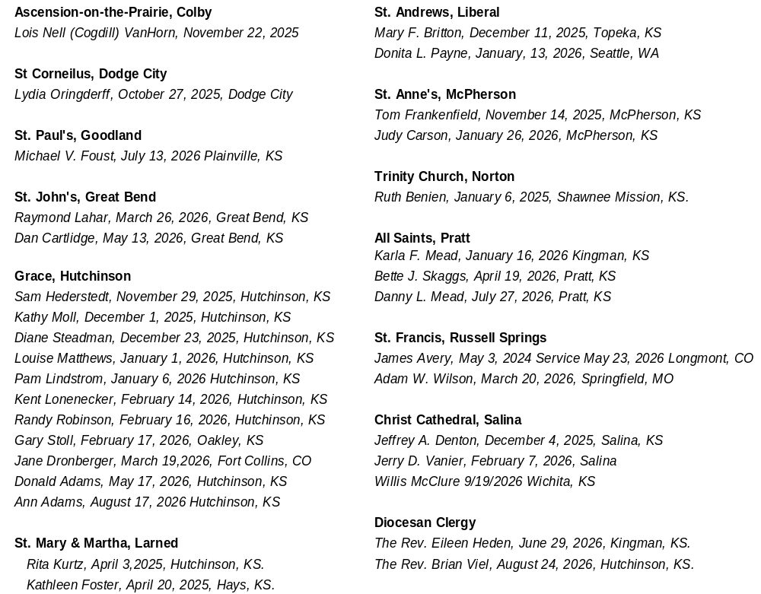

Follow or Post during Convention!



Facebook—Diocese of Western Kansas
Instagram: diowks
When you post something to social media (Facebook, or Instagram) be sure to use the hashtag: #diowks25


We now use

@Dioceseof-WesternKansas



Not receiving the Prairie Spirit Newsletter Prairie in your Inbox?
Scan the QR code and sign up!

